🚀 Day 1 – SQL Challenge | Powered by DPDzero
Started my SQL journey today and learned the most fundamental command — SELECT.
It forms the backbone of data retrieval and helps extract exactly what we need from a database.
💡 Key Concepts Learned
- SELECT — fetches data from a table
- SELECT * — retrieves all columns
- SELECT DISTINCT — removes duplicate values
- Always write clean queries & avoid mixing comments inside SQL lines
🏥 Mini Hospital Database Practice
Worked with patients and services_weekly tables to query real-like healthcare data.
Practiced Tasks & Solutions
1️⃣ Retrieve all columns from the patients table
SELECT * FROM patients;
2️⃣ Select patient_id, name, and age columns
SELECT patient_id, `name`, age
FROM patients;
3️⃣ Display first 10 records from the services_weekly table
SELECT *
FROM services_weekly
LIMIT 10;s
Screenshot of my Work
TASK - 01
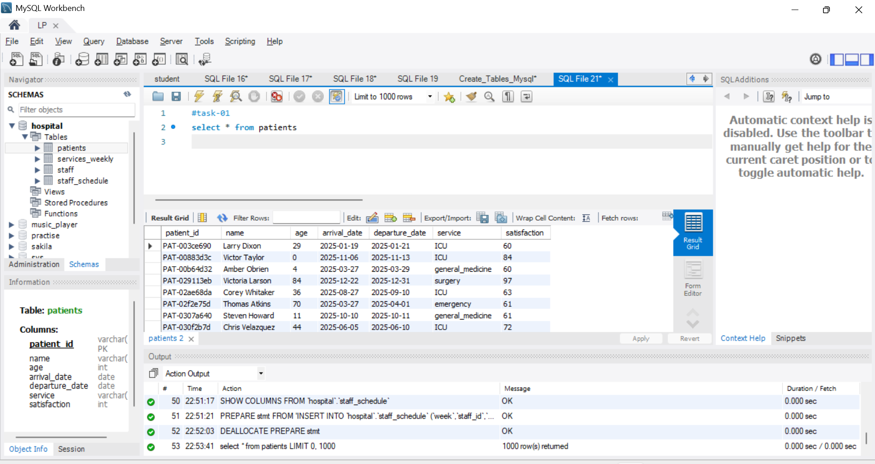

TASK – 02
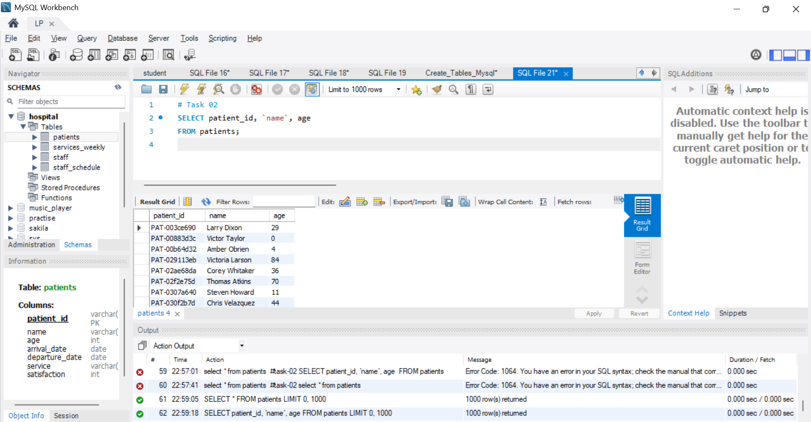

TASK – 03
